CodeX Project Planning Sheet
Pixel Number | Color | Flashing or staying on
0
1
2
3
Buttons | was_pressed or is_pressed? | Action that will occur
Btn-A
Btn-B
Btn-U
Btn-D
Btn-L
Btn-R
LCD Screen | What will show on the screen
Diagram  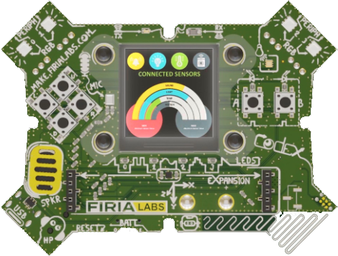 | Pseudocode or flowchart

